PRE A LEVEL COURSE
IN RELIGIOUS PHILOSOPHY (RP)
Philosophy, Ethics and Buddhism

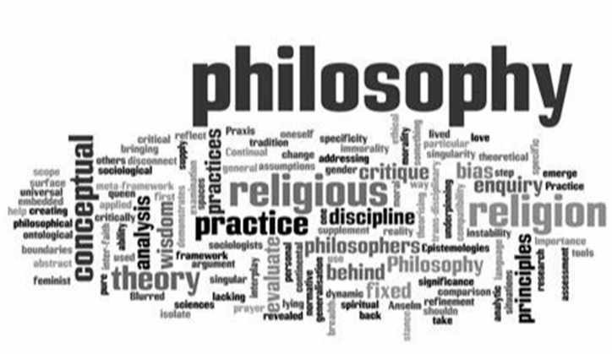

A LEVEL Religious Studies COURSE OUTLINE

The course specification can be accessed here (OCR Specification):

OCR A Level Religious Studies, (Philosophy, Ethics and Buddhism)

(Page 4 onwards described the theory you will be taught)

The course is split into distinct areas with three different teachers taking responsibility for each of the following sections:
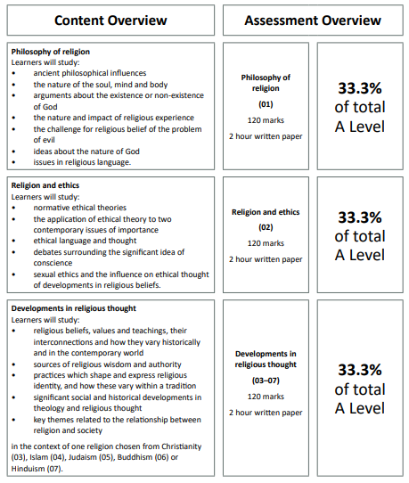

SUMMER TRANSITION WORK

We are so excited to hear that you are hopefully going to be joining us in September to study A Level Religious Studies.
This booklet will give you a brief introduction to the course layout and help you to start getting to grips with some of the key terminology and content so that we can hit the ground running in September.

The first term there are 3 topics we will study. These 3 topics will contribute towards the 3 final exams you will sit in the summer of Year 13.

These three topics are:

- Philosophy of Religion
- Religion and Ethics
- Development in Religious thought (Buddhism)

Please complete the tasks below and bring this completed workbook with you in September. We have also added some links and information about future Career Pathways in Religious Philosophy and Ethics, with links for you to do some research!
Best wishes, EPD Team
*SUMMER TRANSITION WORK HAND IN WEEK: 11th – 15th SEPTEMBER

Task 1. Find out the meaning of the words on the Buddhism phrases and ideas
Using books you have or the internet, research and discover the meaning of each concept. This will supply you with a good grasp of Buddhist language prior to the start of the course.

Anicca:

Arahat/Arhat:

Buddha:

Compassion:

Dana:

Dharma/Dhamma:

Enlightenment:

The Five Skandhas:

Karma/Kamma:

Nirvana/Nibanna:

Paranirvana/Paranibanna:

Samsara:

Sangha:

The Three Poisons (with illustration):

Task 2. Making Ethical decisions - Consider the following scenarios:
- You witness a car crash. The wreckage is burning, but you may be able to save one of the two passengers.
To your horror, you realise that one is your father and the other is a famous cancer specialist on the brink of a breakthrough.
WHO SHOULD YOU SAVE? WHY?
- You are close to a breakthrough with a new medical treatment, but to complete your work you must carry out some particularly slow and painful experiments on animals. WHAT SHOULD YOU DO?

- Your ship goes down and you’re lost in the sea with 3 others, in a life raft. You have no food. There is no
immediate hope of rescue. Two could survive by eating the third: otherwise, all three of you will die.
WHAT SHOULD YOU DO?
- Conjoined twins are born, attached at the abdomen and sharing several major organs.
If nothing is done, both will die. If the twins are separated, one will die and one will live.
WHAT SHOULD BE DONE?
- An unattractive man/woman offers to give a million pounds to the charity of your choice if you spent one night with him/her.
WHAT SHOULD YOU DO?
- How have you made these decisions? Do you think that you have been consistent throughout the process?

- Background reading
- Steven Law’s The Philosophy Files and The Philosophy Gym +
- Read Sophie’s World by Jostein Gaarder
- Podcasts – Ethics Bites from The Open University

Career Pathways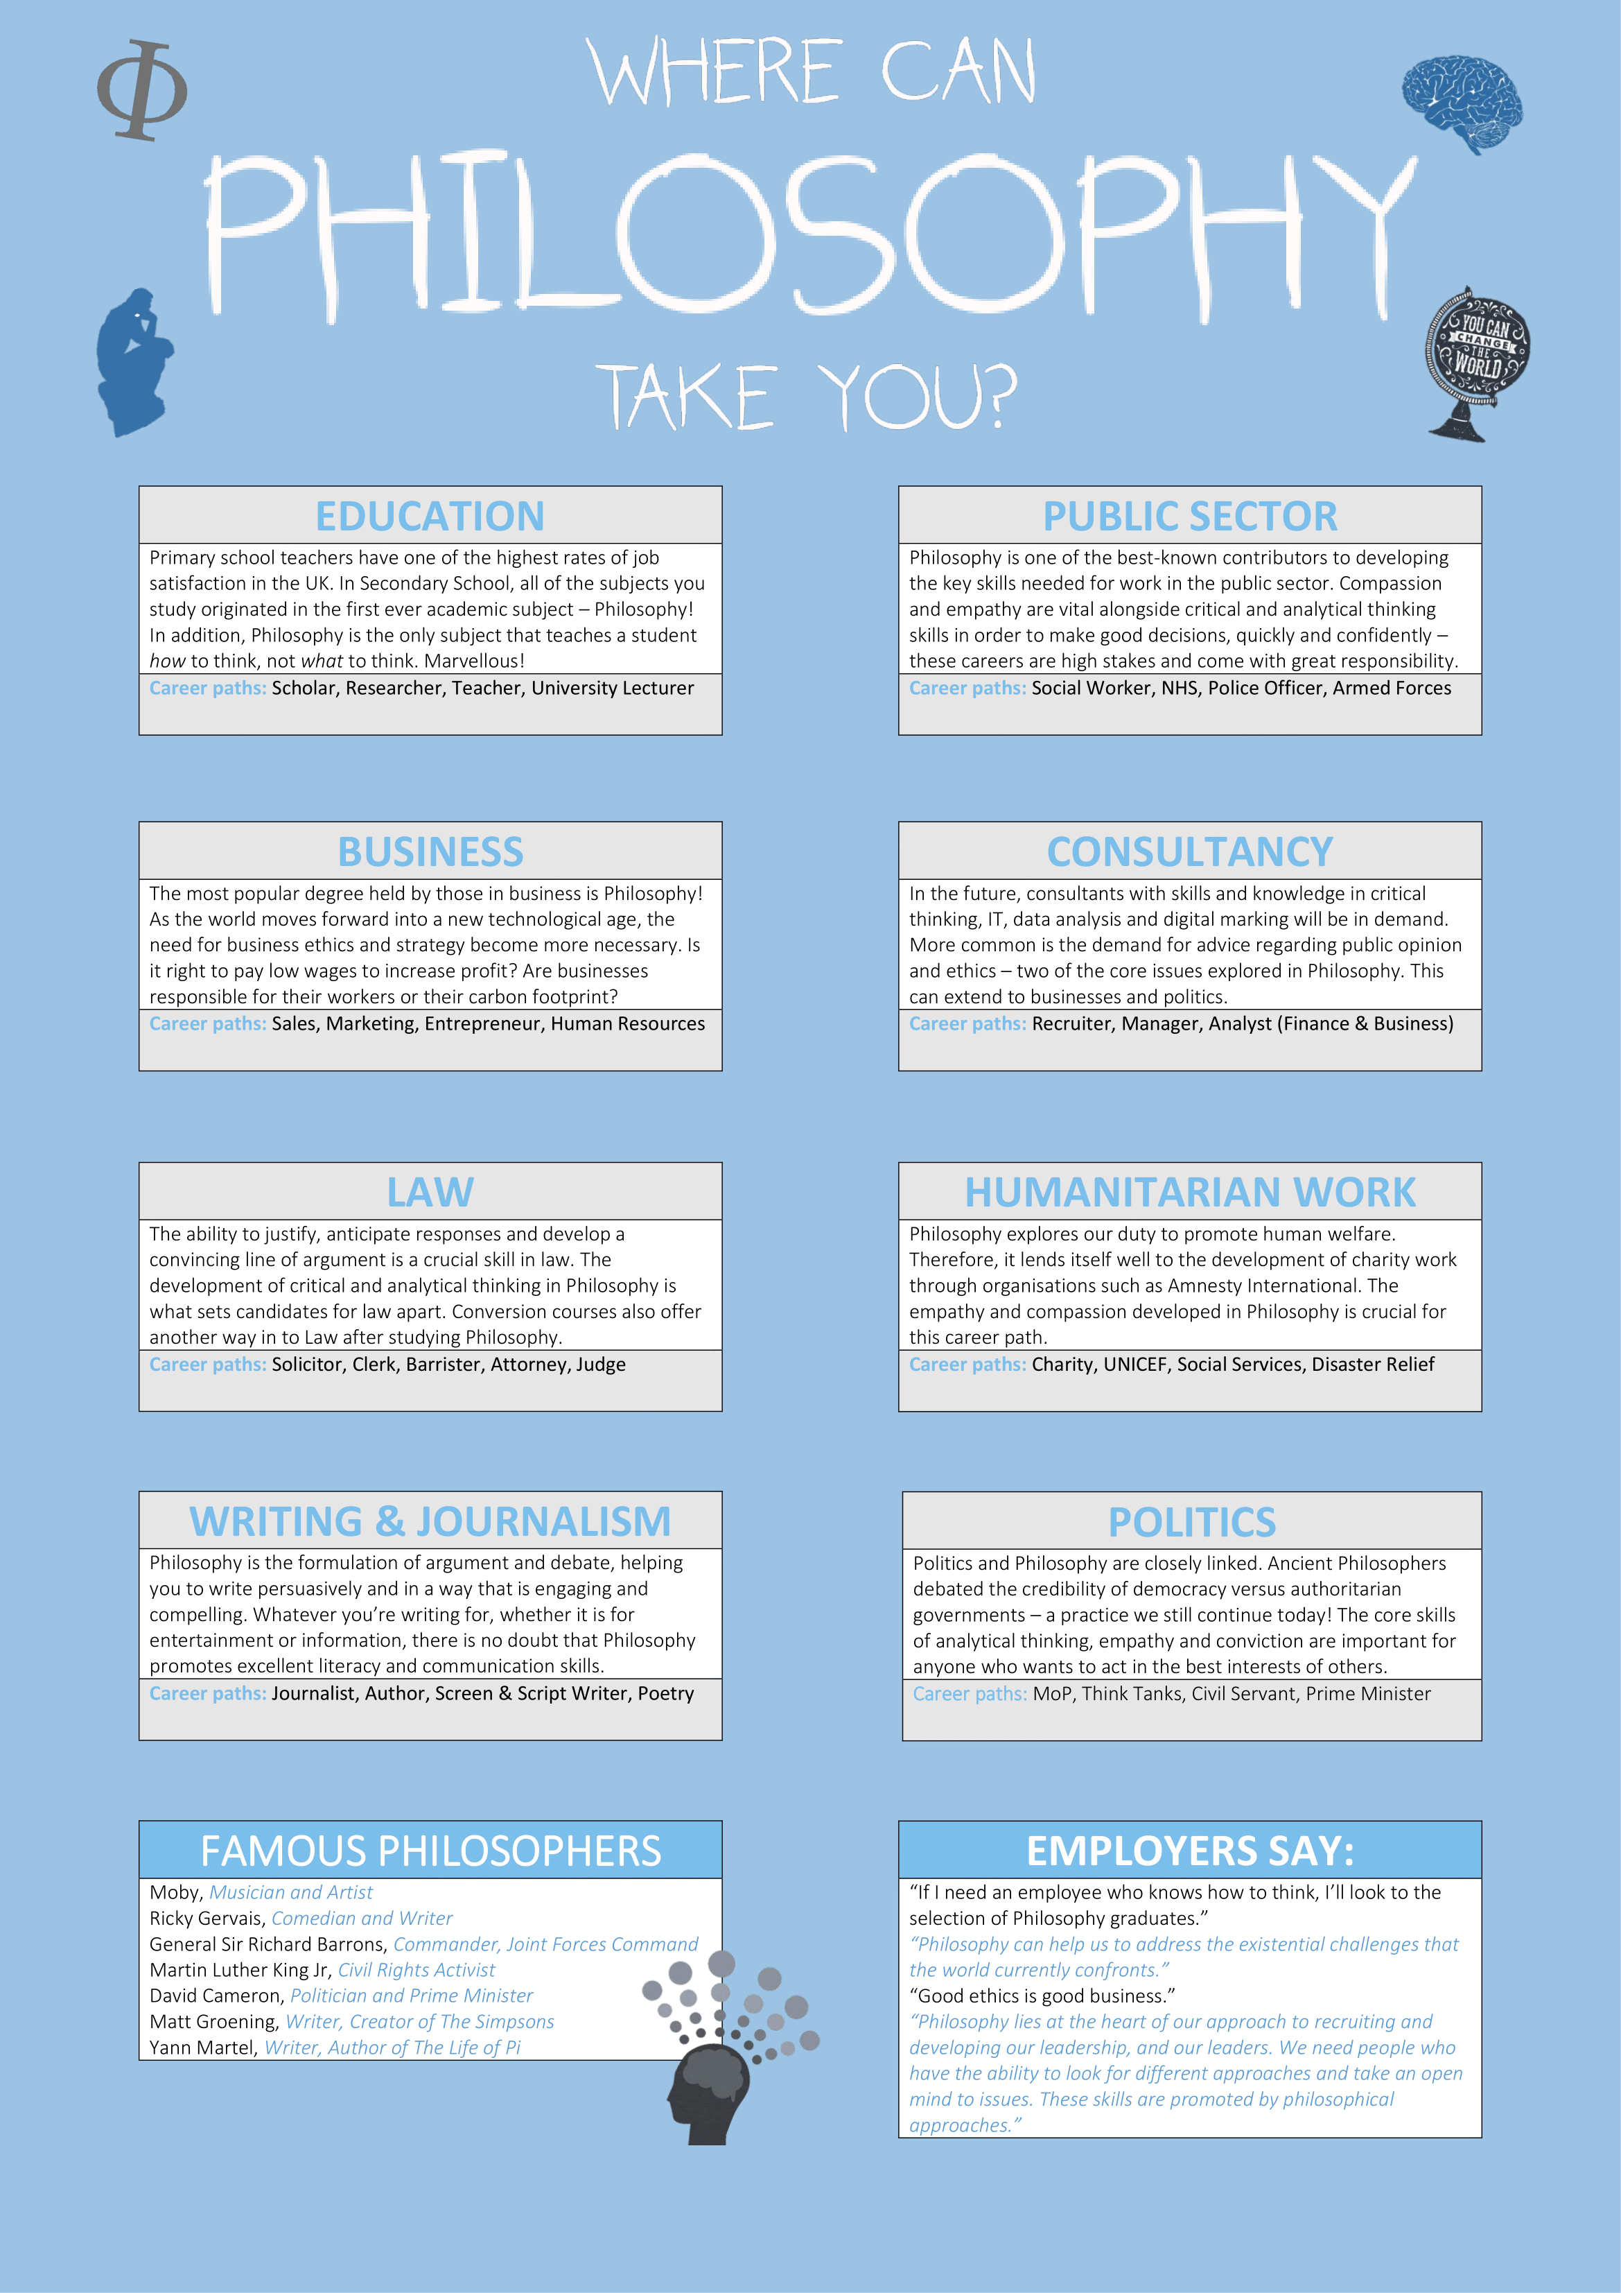
University Pathway: (Click on image and follow the link)
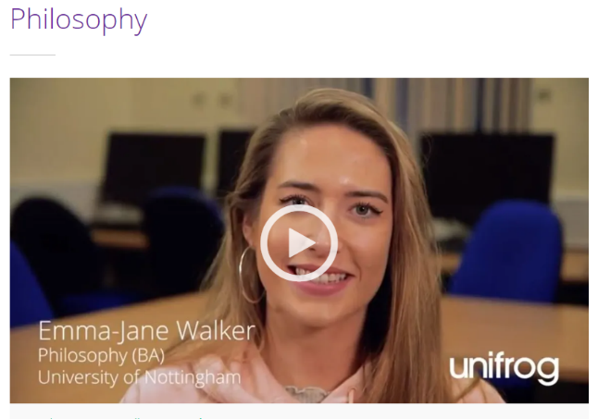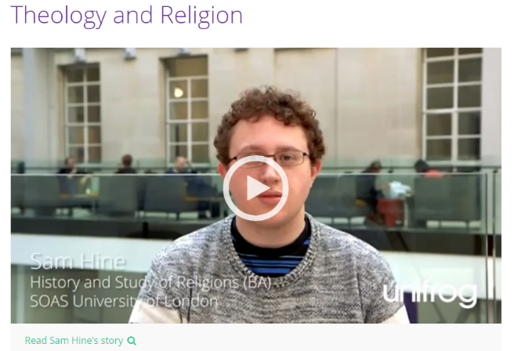

TOP UNIVERSITIES
Theology courses: Theology courses | UCAS
Theology and Philosophy top university
Warwick:
Philosophy: Department of Philosophy - University of Warwick
Exeter:
Philosophy and Theology: Philosophy and Theology BA | Undergraduate Study | University of Exeter
Durham:
Philosophy and Theology: VV56 - Durham University
Manchester:
Philosophy: BA Philosophy (2024 entry) | The University of Manchester
Theology and Religion:
Durham: V614 - Durham University
Manchester: BA Philosophy and Religion (2024 entry) | The University of Manchester

LOCAL AREA
Winchester:
Philosophy, Religion and ethics: BA (Hons) Philosophy, Religion and Ethics - University of Winchester
Philosophy of Education: MA Philosophy of Education - University of Winchester
Philosophy: BA (Hons) Philosophy - University of Winchester
Chichester
Philosophy and Ethics: BA (Hons) Philosophy and Ethics - University of Chichester
Southampton
Philosophy, Ethics and Religion: Philosophy, Ethics & Religion | University of Southampton

DEGREE APPRENTICESHIP
Warwick:
Social work: BA (Hons) Social Work Degree Apprenticeship (warwick.ac.uk)

Apprenticeship Routes
Apprenticeships typically consist of 80% on-the-job training, and 20% studying. For some opportunities this means 4 days per week at the workplace and 1 day at a college, and for others this means you will work for about 10 months a year, then you'll spend 2 months just studying. Apprenticeships using Religion or Philosophy tend to be in either the health and wellbeing sectors or Public Services. Some links are below:
Health and wellbeing apprenticeships | The Apprenticeship Guide
The Apprenticeship Guide | Public services apprenticeships

